**INTRODUCTION TO NETWORKING**

ASSIGNMENT **01**



SPRING 2025

**DATA COMMUNICATION AND COMPUTER NETWORKS**

SUBMITTED BY:

**MUHAMMAD MUSA**

REGISTRATION NO:

**22PWCSE2157**

SECTION: **C**

SUBMITTED TO:

**ENGR. IHSAN UL HAQ**

Dated: **07thApril, 2025**

DEPARTMENT OF COMPUTER SYSTEMS ENGINEERING

UNIVERSITY OF ENGINEERING AND TECHNOLOGY, PESHAWAR

CSE 303: Data Communication and Computer Networks

Graded Assignment No 1

Assignment Date: 3rd April,2025

Strict Deadline 8th April 2025 (During Class, After the class Assignment will not be accepted)

1. Click the following link, read and understand the material. Answer all questions given in the link and submit https://tryhackme.com/room/networkingconcepts

2. Click and watch the vedio link. Moreover, click the following link, read and understand. Answer all questions given in the link and submit i) https://www.youtube.com/watch?v=42u_2e6eNF4&t=9s

ii) <https://tryhackme.com/room/whatisnetworking>

* **Objective:**  
  The primary objective of this is to understand the concept of networking, its components, types, and the role it plays in enabling communication and data sharing between devices.
* **Introduction:**  
  Networking refers to the practice of connecting multiple computing devices, such as computers, servers, printers, or mobile devices, to enable communication and the sharing of resources. Networks facilitate the transfer of data and allow devices to communicate with each other through different mediums like cables, wireless signals, or fiber optics. There are several types of networks, ranging from small local area networks (LANs) to large wide area networks (WANs) and the internet.
* **Click the following link, read and understand the material. Answer all questions given in the link and submit** [**https://tryhackme.com/room/networkingconcepts**](https://tryhackme.com/room/networkingconcepts)

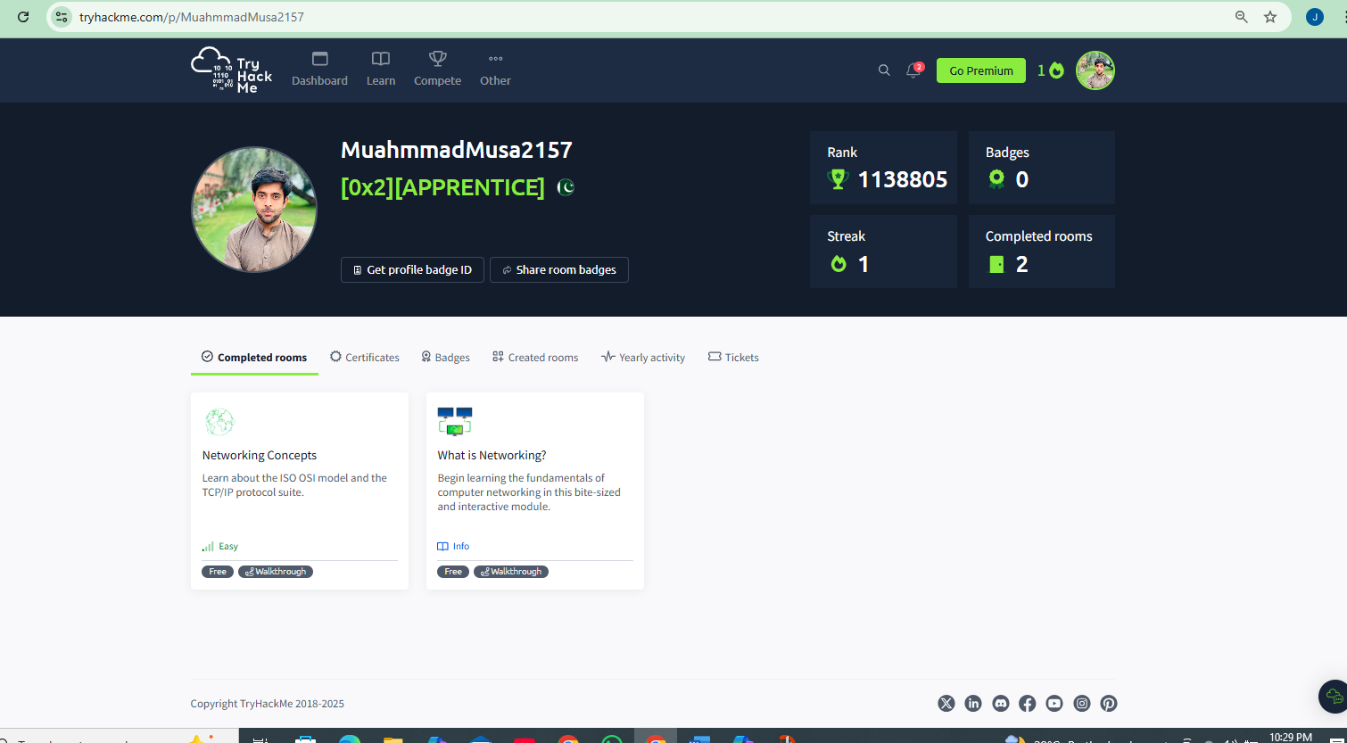

**Networking Concept**

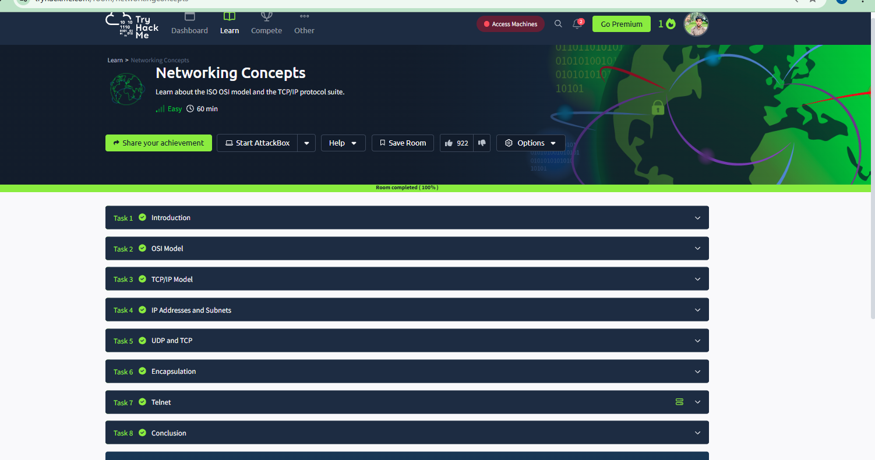

Task 01:

**Question 1:**

Which layer is responsible for end-to-end communication between running applications?

Ans :4

**Question 2:**

Which layer is responsible for routing packets to the proper network?

Top of Form

Ans 3

**Question 3:**

In the OSI model, which layer is responsible for encoding the application data?

Top of Form

Ans :6

Which layer is responsible for transferring data between hosts on the same network segment?

Top of Form

Ans :2

TASK #02: **TCP/IP Model**

**Question 1:**

Which layer is responsible for end-to-end communication between running applications?

Ans : 4

**Question 2:**

Which layer is responsible for routing packets to the proper network?

Top of Form

Ans :3

**Question 3:**

In the OSI model, which layer is responsible for encoding the application data?

Top of Form

Ans :6

**Question 4:**

Which layer is responsible for transferring data between hosts on the same network segment?

Top of Form

Ans :2

**Task : 3 TCP/IP Model**

1. To which layer does HTTP belong in the TCP/IP model?

Ans : Top of Form

Application Layer

1. How many layers of the OSI model does the application layer in the TCP/IP model cover?

Top of Form

Ans :3

**Task :4** **IP Addresses and Subnets**

1. Which of the following IP addresses is not a private IP address?

Ans : 49.69.147.197

1. Which of the following IP addresses is not a valid IP address?

Ans: 192.168.305.19

**Task # 05 UDP and TCP**

1. **Which protocol requires a three-way handshake?**

Top of Form

TCP

1. What is the approximate number of port numbers (in thousands)?

Top of Form

65

**Task # 06 Encapsulation**

1. On a WiFi, within what will an IP packet be encapsulated?

Ans: Frame

1. What do you call the UDP data unit that encapsulates the application data?

Top of Form

Ans: Datagram

1. What do you call the data unit that encapsulates the application data sent over TCP?

Top of Form

Ans : Segment

**Task #0 7 Telnet**

1. Use telnet to connect to the web server on 10.10.176.34. What is the name and version of the HTTP server?

Ans: lighttpd/1.4.63

1. What flag did you get when you viewed the page?

Top of Form

Ans: THM{TELNET_MASTER}

**Task 08 Conclusion:**

In this room, we covered the ISO OSI and TCP/IP models, comparing and contrasting the two. We also covered IP addresses and subnets, briefly explaining routing. Furthermore, after diving into TCP and UDP, we explained encapsulation. For demonstration purposes, we used telnet to “talk” to different servers over TCP.

**What is Networking?**

Task 01 What is Networking?

What is the key term for devices that are connected together?

Top of Form

Ans :Network

Task 02 What is the Internet?

1. Who invented the World Wide Web?

Ans:Top of Form

Tim Berners-Lee

**Task 03 Identifying Devices on a Network**

1. What does the term "IP" stand for?

Ans: Internet Protocol

1. What is each section of an IP address called?

Top of Form

Ans: Octet

1. How many sections (in digits) does an IPv4 address have?

Top of Form

Ans :4

1. What does the term "MAC" stand for?

Top of Form

Ans: Media Access Control

**Task :04 Ping (ICMP)**

1. What protocol does ping use?

Ans: ICMP

1. What is the syntax to ping 10.10.10.10?

Ans: ping 10.10.10.10

1. What flag do you get when you ping 8.8.8.8?

Top of Form

Ans: THM{I_PINGED_THE_SERVER}

**Task :05 Continue Your Learning: Intro to LAN**

Ans: No Answer needed

**Top of Form**

**Top of Form**

**Top of Form**